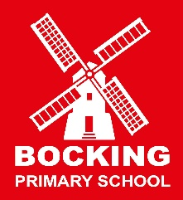
Curriculum

Attain Academy Partnership - ‘Working together towards success for all’

Vision and Purpose
Attain Academy Partnership aims to provide an outstanding education for all children in all schools, relevant to the world in which they live. We would like all members of Attain to become:
- Ambitious, capable learners who are resilient and independent
- Enterprising, creative contributors who have a real love of learning
- Ethical, informed citizens who value differences and inclusivity
- Healthy, confident individuals who contribute to a mutually supportive environment
At Bocking:
Our curriculum has been created to ensure our children are prepared for learning beyond their time at Bocking Primary with a focus on a foundational knowledge, skills, and understanding that will serve pupils throughout their lives. Based on the national curriculum requirements, it is ambitious and we ensure that we build on each child’s strengths and are inclusive of all learners promoting a diverse and supportive learning environment. Our curriculum develops our children’s essential knowledge, skills and understanding which will ensure that they are equipped for lifelong learning; such experiences can make learning more meaningful and practical.
We believe that our children deserve every opportunity to develop their knowledge and understanding of the wider world through real-life experiences and cultural enrichment which can help students develop a global perspective and appreciate different cultures. Creating a secure environment that nurtures children's confidence is a crucial factor in enabling them to develop into independent learners and critical thinkers who take pride in their achievements. This aligns with the aim of preparing pupils for a future where adaptability and problem-solving are essential skills. Improving outcomes for all learners is fundamental to our curriculum design and implementation ensuring that every child can succeed. Alongside this focus on academic outcomes, our curriculum is designed to develop the whole child not just academically but also socially, emotionally, and personally.
We will
- Develop collaborative learning between all
- Provide a broad and balanced provision of all subjects
- Enable all pupils to achieve well promoting high aspirations and ambition
- Nurture personal attributes and facilitate life skills in preparation for their future
This will be achieved by our underlying principles that are at the heart of our curriculum planning.

Principles:
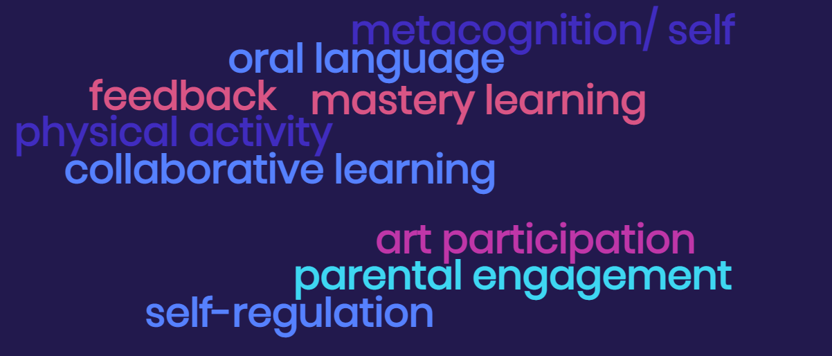
Metacognition:
Leads to improved learning, problem-solving, decision-making, self-awareness, and critical thinking. It is a valuable skill set that can enhance various aspects of cognitive and intellectual functioning, ultimately leading to more successful and adaptable individuals in both academic and real-world contexts.
Oral Language:
Improved communication, academic success, critical thinking, social skills, confidence, career opportunities, cultural competence, and the ability to navigate various aspects of life effectively. Fostering strong oral language skills is essential for personal and professional growth and for building strong connections with others.
Feedback:
Improved performance, increased self-awareness, enhanced learning, motivation, personal growth, effective communication, goal achievement, accountability, continuous improvement, conflict resolution, relationship building, quality assurance, and innovation. Utilising feedback effectively is essential for individual and organisational development.
Mastery Learning:
Achieving a deep understanding, high proficiency, reduced achievement gaps, long-term retention, improved problem-solving skills, greater self-efficacy, personalised learning, higher academic achievement, increased engagement, and the ability to apply knowledge in diverse contexts. Mastery learning aims to provide a solid foundation for pupils to succeed academically and in their future endeavours.
Physical Activity:
Integrating physical activity into a balanced curriculum that includes a variety of teaching methods and subjects ensures that learning is accessible and inclusive for all pupils maximizing its positive impact on education.
Collaborative Learning:
Fostering a supportive and interactive learning environment that not only enhances academic achievement but also equips pupils with valuable life skills that can benefit them in various aspects of their personal and professional lives in the future.
Art Participation:
Contributes to a well-rounded education, fostering holistic development in pupils and equipping them with skills and perspectives that extend beyond the classroom.

Parental Engagement:
Parental involvement extends beyond the classroom, influencing a child's overall development, behaviour, and future success also strengthening the partnership between home and school, creates a more enriching educational experience for pupils.
Self-Regulation:
Individuals take charge of their education, adapt to different learning contexts, and develop skills that are valuable not only in school but throughout their lives and careers. It fosters independence, motivation, and the ability to learn effectively in an ever-changing world.
_______________________________________________________________________________________________
Through our broad curriculum, new learning and opportunities to take risks will help to build resilience; curiosity and originality to ensure that our children have the resilience to learn from their mistakes; have the ability to be active learners and have the social skills to be respected and caring members of their community.
We have recognised the need for our children to have further opportunities to build on their skills and have identified 4 areas of learning that will be a focus throughout the curriculum. The Edison Learning and Life Skills are a coherent set of Learning Units designed to ensure pupils learn effectively and are equipped for lifelong learning, no matter their Key Stage, or their age. These are interwoven throughout the curriculum and taught as explicit objectives, dependent on the children’s needs.
Our focus is centred around 4 key life skill areas which we identified at Bocking. These are covered in the Edison Learning and Life Skills programme of study.
I am a Communicator | I am Reflective | I am a Problem-solver | I am a Teamplayer
- Public speaking  - Listening and responding  - Knowing your audience  - Negotiating  - Being articulate  - Responding  - Self management  - Focus  - Flexible to circumstance | - Motivated  - Self-management  - Driven  - Willingness  - Evaluative  - Listen  - Open-minded  - Inner-strength  - Passion  - Negotiate  - Desire to improve  - Mediate  - Empathy  - Responsive | - Initiative  - Stamina  - Challenge  - Adaptability  - Maintaining focus  - Flexibility  - Observe  - Reflective/  Evaluative  - Making connections  - Systematic  - Logical  - Organised  - Strategic | - Listening and responding  - Leadership  - Organisation  - Negotiation  - Teamwork  - Listening  - Self-motivated  - Considerate  - Repeating others  - Supportive  - Celebrating others  - Challenge yourself  - Mediate  - Turn-taking

Each of the six Learning Units contains teaching strategies, learner activities and a bank of progressive ‘I can’ statements divided into the skill areas to be used from EYFS to the end of KS2. This framework supports the intentional and systematic development of pupils’ independent learning and social/life skills.

Each one of these Learning Units provides the focus for half a term. The skills from each Learning Unit are introduced discretely and teachers then plan to provide opportunities for pupils to develop and use these skills further to support their learning across all subjects of the curriculum.
The progressive ‘I can’ statements can be used by pupils and teachers as learning objectives and/or targets supporting the small steps in the development of skills for learning and for life.

It is important that our curriculum for Key Stage 1 builds on the child-initiated ethos of the Early Years Foundation Stage principles. Pupils should be active partners in developing the curriculum. Their questions, interests and ideas are therefore utilised to develop and enhance planned learning experiences through our weekly Class Learning forums.
Throughout Key Stage 1 and Key Stage 2 a wide variety of teaching and learning approaches and styles are used to promote pupil engagement with the curriculum. Staff regularly utilise a range of high-quality resources to encourage independent learning and inspire pupils. The use of the whole school environment, both inside and outside, is also used regularly to enrich the curriculum. We take advantage of partnerships with the parent, local, national communities when these will create real and meaningful contexts within the curriculum for the pupils. This is done through real and virtual experiences that enable pupils to have valuable experiences without physical barriers.
The varied pedagogical approaches used to deliver the curriculum also support the development of learner skills. For example, children are given opportunities to learn collaboratively with their peers using Kagan techniques, this is then embedded through regular, independent practice. Whilst most subjects are taught thematically, we encourage learners to make links across subjects, some areas of study are more appropriately taught discretely, such as MfL, computing or music.
Learners will develop the skills of enquiry and critical thinking across subjects such as history, RE, English, science and geography and, alongside the arts, develop and embed a rich and ever-growing vocabulary. We recognise the importance of tailoring our curriculum to the needs of the learners and families in our school community. We therefore ensure that there is a focus on vocabulary development and enrichment across the curriculum in all year groups. This is taught through drama, as well as being embedded in our English lessons in the classroom. Our curriculum is designed so that Personal, Social, Health and Emotional learning (PSHE) runs through all topics as well as stand alone lessons. We also look continually for new opportunities to engage parents and carers with their child’s learning, through workshops, forums, clubs and regular celebrations of learning throughout the school year.
Roles and Responsibilities
The Headteacher maintains an overview of the curriculum provided by the school and works in partnership with the Senior Leadership Team on a range of strategic planning, monitoring and evaluating tasks, from the full range of evidence provided by other staff and governors.
Subject Leaders ensure that all the aspects of the National Curriculum content are identified within the curriculum overviews. Subject Leaders review the progression maps to ensure that pupils’ learning becomes increasingly more challenging as they move through the year groups, and to maintain an overview of standards within their subject.
Subject Leaders also produce action plans for their subjects, support the writing of medium-term plans of class teachers, analyse the standards within their subject, identify training needs and resources and engage in developmental work / research projects with external colleagues.
Class Teachers have the final responsibility to produce class specific, medium and short term planning for their pupils. They also have responsibility for the standards their pupils achieve, the progress they make and the evidence of this learning. Class teachers should ask for guidance from Subject Leaders when appropriate and are required to ensure all provision promotes an inspiring and exciting curriculum.
Underpinning everything we do in our curriculum are our values;

I am: Ambitious, Respectful, Responsible, Engaged and I Persevere

